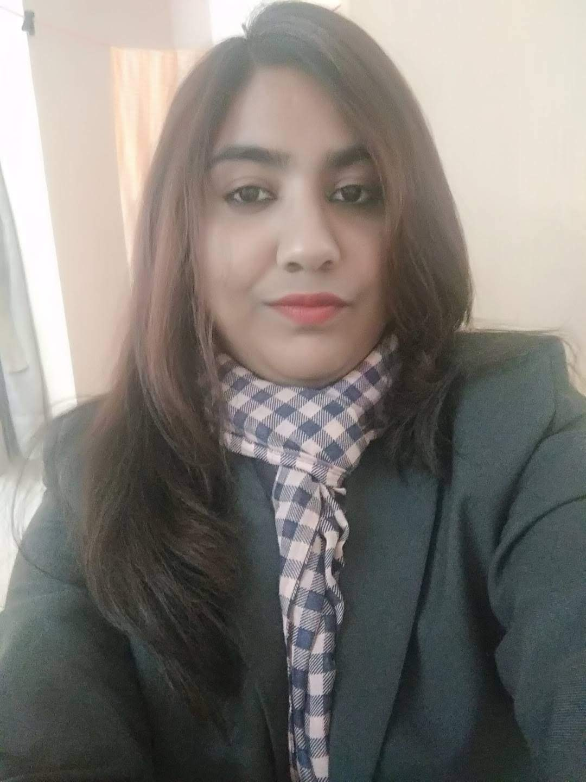

**HOMA FIRDAUS**

**Communication Address:** Nagmatiya Road, Near Railway Cinema, Gaya, Bihar

**Mobile NO**: 9262941951   
**Email:** firdaushoma1@gmail.com

**_______________________________________________________________________________________________**

**PROFILE**

An ambitious Management Professional with strong commitment to pursue career in management. Aiming to secure a good place on a post-graduate scheme, which can provide exposure and opportunities for progression.

**CAREER OBJECTIVES**

To carve a niche for myself and being the foremost player in the world of Management and working in a good environment where one faces new challenges every day.

WORK EXPERIENCE

1. **BYJU’S**: Working with Byju’s as Pre sales Associates.

**KEY RESPONSIBILITIES**:

* Setting up scheduled Demos or Online meetings of prospects with our Academic Counsellors.
* Updating updating task/activities/ relevant information various company platforms (e.g. LS, CRM, reporting)
* Briefing them about the program they have selected or shown interest for. Counsel the students and parents on learning pedagogies and the BYJUS personalised learning journey.

1. **BANDHAN BANK** : 1st july 2020 to 6th January 2021 Customer Relationship Officer, Retail Branch Banking

**Role**: Responsible for providing high quality service and query resolution to the customers of the bank, proactively and convert service opportunity into a sales opportunity.

**KEY RESPONSIBILITIES**:

• Ensure individual level targets related to value and numbers of accounts are met

• Ensure targets related to third party products are met

• Ensure that the customer query are attended to and resolved in an efficient manner and within stipulated Turn Around Time (TAT)

• Improve customer communication on closures through scripts & mails

• Understand and comply with requirements of all relevant policies of the bank including full compliance with Know Your Customer (KYC) and Anti Money Laundering (AML) requirement.

**ACADEMIC QUALIFICATIONS**

|  |  |  |  |  |  |
| --- | --- | --- | --- | --- | --- |
| **YEAR** | **DEGREE / CERTIFICATE** | **BOARD / UNIVERSITY** | **SCHOOL / COLLEGE / INSTITUTE** | **SUBJECT STUDIED / SPECIALIZATION** | **MARKS / GRADE OBTAINED** |
| 2020 | PGDM | AUTONOMOUS AICTE APPROVED | CALCUTTA BUSINESS SCHOOL | MARKETING&HR | 6.5 out of 9, CGPA |
| 2016 | BSC | MAGADH UNIVERSITY | MIRZA GHALIB COLLEGE ,GAYA | ZOLOGY HONS | 62% |
| 2013 | ISC | BSEB | HADI HASHMI+2 HIGH SCHOOL, GAYA, BIHAR | PCMB | 64% |
| 2011 | 10th | CBSE | GYAN BHARTI PUBLIC SCHOOL, GAYA, BIHAR | GENERAL | 8.2 CGPA |

**INTERNSHIP DETAILS**

|  |  |  |
| --- | --- | --- |
| **INTERNSHIP** | **NAME OF THE ORGANIZATION** | **PROJECT TITLE** |
| AUTUMN INTERNSHIP | WACKER’S METROARK CHEMICAL | EMPLOYEE MANUAL |
| SUMMER INTERNSHIP | IMRB- KANTAR | MARKET SURVEY FOR CUSTOMER’S OPINION. |

**KEY SKILLS**

* Good **teamwork skills**.
* Communication skills and networking ability.
* Adaptability.
* Organizing and planning skills.
* Commercial awareness.
* Numerical skills
* Maintaining websites and looking data analytics
* Organizing events and product exhibitions
* Updating databases and using a Customer relation management (CRM) system

**COMPUTER KNOWLEDGE**

* MS-EXCEL
* MS-WORD
* MS-POWERPOINT

**EXTRA-CURRICULAR WORKS**

* Event Representative of Calcutta Business School.
* Cultural Events
* Extempore

**LANGUAGES KNOWN**

* English
* Hindi

**HOBBIES & INTERESTS**

* Acting
* Social Activity

**PERSONAL DETAILS**

* **Father’s Name:** MD Iftekhar Ahmad
* **Mother’s Name:** Tabassum Naz
* **Nationality:** Indian
* **Marital Status:** Single
* **Gender:** Female
* **Date of Birth:** January, 18, 1997

**I hereby declare that the information provided here are true to the best of my knowledge.**

**Date:** 25th of july, 2021 Signature

C:\Users\muntakhab\Desktop\IMG-20180713-WA0001-01.jpeg